 9/2017

PARENT/GUARDIAN: SCHEDULING TEACHER CONFERENCES
*****CONFERENCES CANNOT BE SCHEDULED FROM MOBILE DEVICES*****
LOGIN TO SKYWARD USING YOUR PARENT LOGIN AND PASSWORD. YOU WILL NOT BE ABLE TO MAKE AN APPOINTMENT IF YOU ARE LOGGING IN AS YOUR STUDENT.
Choose “Conferences”
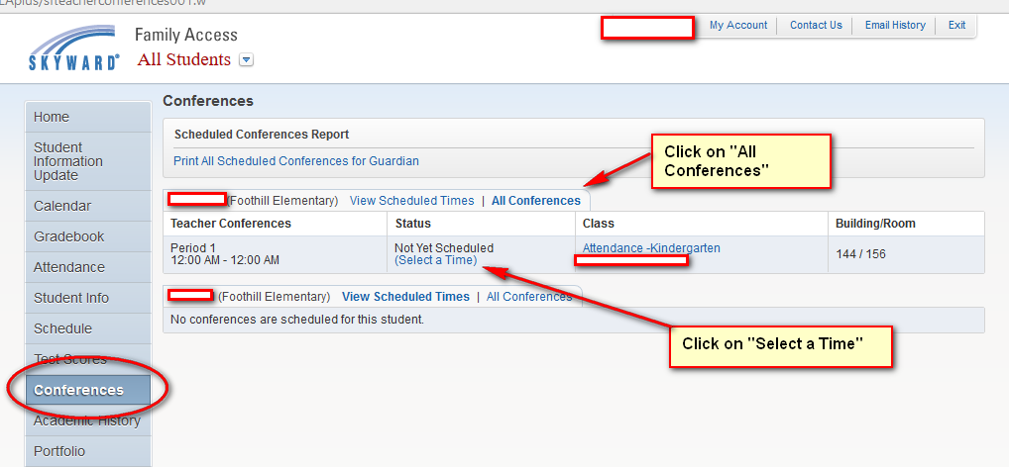

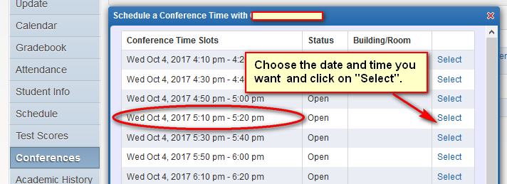
*****If the “Select” button does not work for you, it may be your Browser that is blocking it. Google Chrome can be a problem at times. Firefox works the best.*****

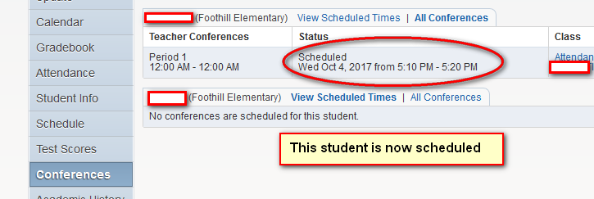
To remove or change your appointment click on “View Scheduled Time” and “Unschedule”.
Your Parent Teacher conference is now scheduled for this student.
You can print your scheduled Conferences for all of your children.
